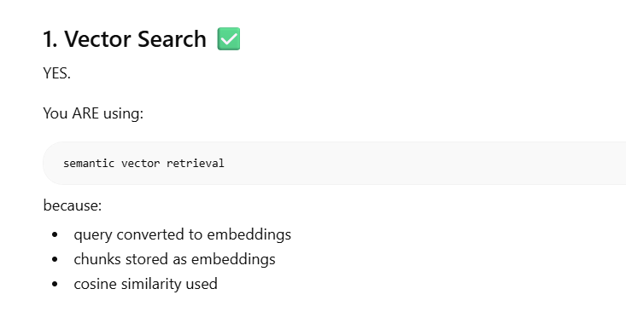

Along with Vector Search , one can add metadata filtering, with the query, so that from 100s chucks, first based on metadata filter’s chucks are selected and then vectors are matched.
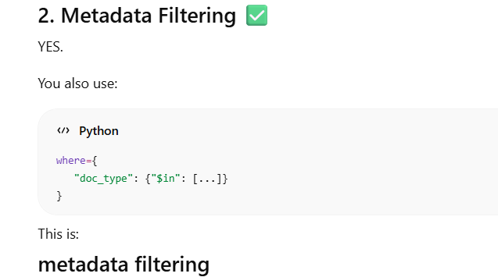

To make retrieval more interesting, we have other tools too:
Why ? Because lets see:
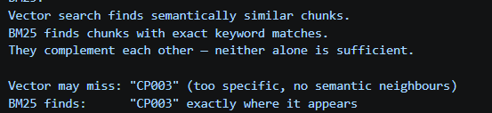
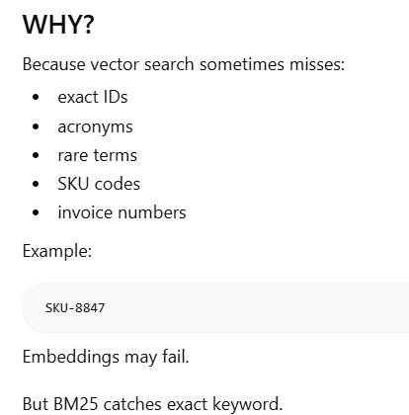

So After vector search and metadata filtering, we have:
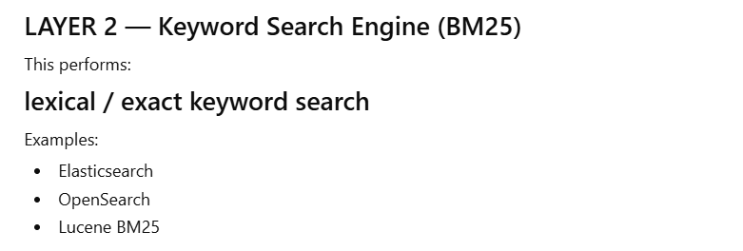
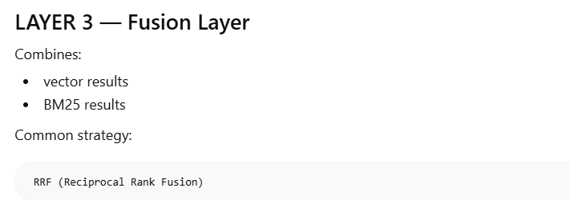
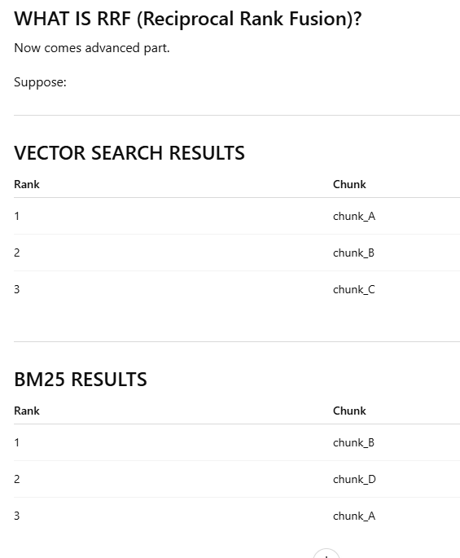
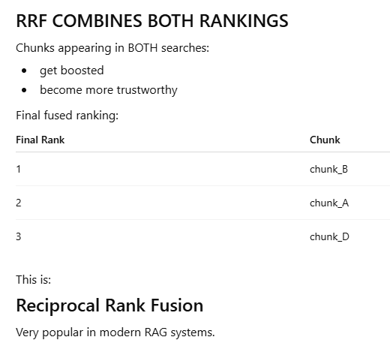
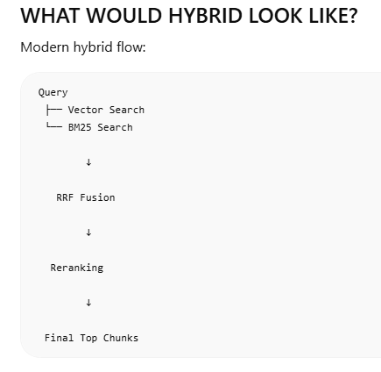

Future Learning:
WHAT ABOUT ELASTICSEARCH / OPENSEARCH?
These are:
enterprise search engines
Very powerful.
They already include:
- BM25
- filtering
- indexing
- hybrid search support
WHEN ELASTICSEARCH MAKES SENSE
Use when:
- millions of docs
- enterprise scale
- log analytics
- advanced filtering
- distributed infra

WHAT ABOUT QDRANT HYBRID?
Qdrant now supports:
native hybrid retrieval
Meaning:
- vector search
- BM25-like sparse retrieval
inside same engine.
VERY modern architecture.
WHAT ABOUT WEAVIATE HYBRID?
Same idea:
- vector search
- BM25
- hybrid ranking
built-in.
Very enterprise-grade.

BUT IMPORTANT INSIGHT
These systems:
Qdrant Hybrid
Weaviate Hybrid
already internally implement:
- vector search
- keyword search
- fusion logic
B. RAG Evaluation
Learn:
- precision@k
- recall@k
- hit rate
- reranking evaluation
Very important now.

